The equation of spider web
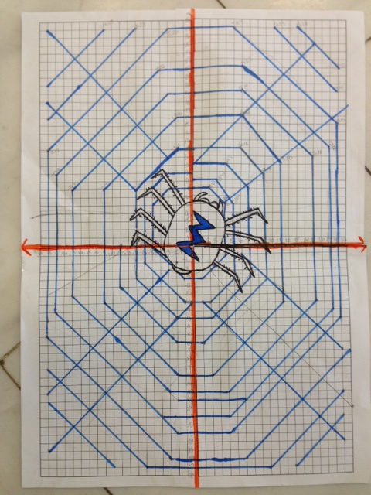
Driving Question: How do you make an image by using functions and graphing them?
Materials:
● Graphing Paper
● Colors
● Poster
In this project, I created a spider web with 20 lines and I wrote their equations.

number of lines | slope | y- intercept | Equation of the line
1 | 1 | `8 | Y=1x+(-8)
2 | 1 | -10 | Y=1x+(-10)
3 | 1 | -12 | Y=1x+(-12)
4 | 1 | -17 | Y=1x+(-17)
5 | 1 | -22 | Y=1x+(-22)
6 | -1 | -7 | Y=-1x+(-7)
7 | -1 | -10 | Y=-1x+(-10)
8 | -1 | -12 | Y=-1x+(-12)
9 | -1 | -17 | Y=-1x+(-17)
My Website | My Video

